  “River Rumble” Minigaine  20 March 2011  Control Card |  | Entrant Name .................................................... Number ...........  Start ................. Finish ................ Time Elapsed .................  Gross Score ...............  Time Penalty (20 points/minute (or part) over 3 hours) minus ...............  Final Net Score ...............

Notes

- Take extreme care when crossing roads. Please use footpaths, traffic lights and pedestrian crossings wherever possible. Some roads will be very busy, especially Yanko Road, Comenarra Parkway and Talavera Road.
- Take care with river and stream crossings, especially near X3, X4 and 86 (and especially if it rains before the event). Note that the track from X3 up to 29 is indistinct (it’s clearer to go from 29 down to X3).
- Do not enter restricted areas– especially in the vicinity of the M2 Freeway, Turramurra High School buildings, West Pymble School and fenced areas in Macquarie University. Also, do not enter private property, including residential and commercial premises.

- The map is not completely accurate. Cliffs and rocks have been deleted to improve clarity of the location of bush tracks. Some minor tracks are not shown and some tracks will not indicate every twist and turn. (Thanks to Garingal Orienteers for providing the map).
- The Controls at or near the five crossings of the Lane Cove River (X1 to X5) score 100 points each. Visit four of these Controls and you score 250 Bonus Points.
- You also score 50 Bonus Points for each Control you correctly identify at or near where a photograph has been taken. (You must actually visit the Control).
- The total number of points is 6250.

- This is a 3 hour event. If you return after 3 hours your will incur a penalty of 20 points for each minute, or part, that you late.
- The mass start is at 3pm. but you can start anytime after 12:30pm. If you start before 3pm, have the Starter record your Start Time on your Control Card.
- When you return make sure you go immediately to the Finish and have your Finish Time recorded.
- After you have finished, add up your Gross Score, deduct any Time Penalty, record you’re Final Net Score and return your Control Card to the collection box. Scoring is based on an honour system.

- Please stick around and enjoy the free BBQ and eats.
- Also, you are most welcome to stay for the Annual General Meeting of the NSW Rogaining Association, starting at 6:30pm.
- We hope you enjoy the River Rumble.

Bonus Points
Visit and identify the Control, at or near where the photograph was taken - 50 Bonus Points each.

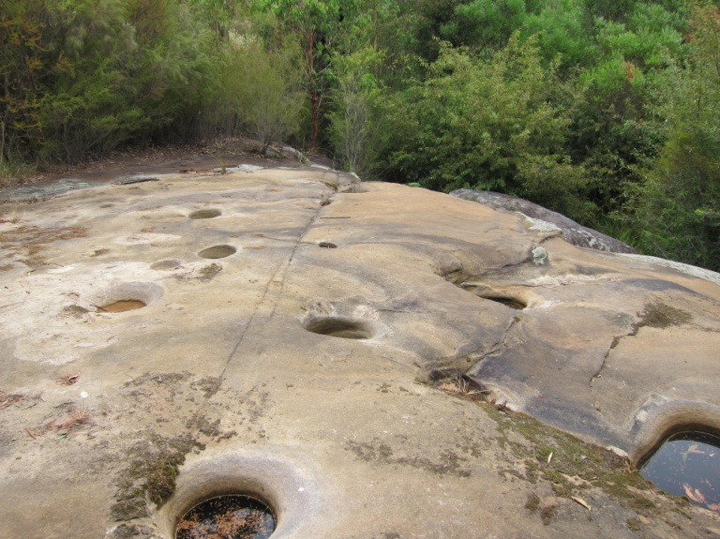  Control ...52..... | 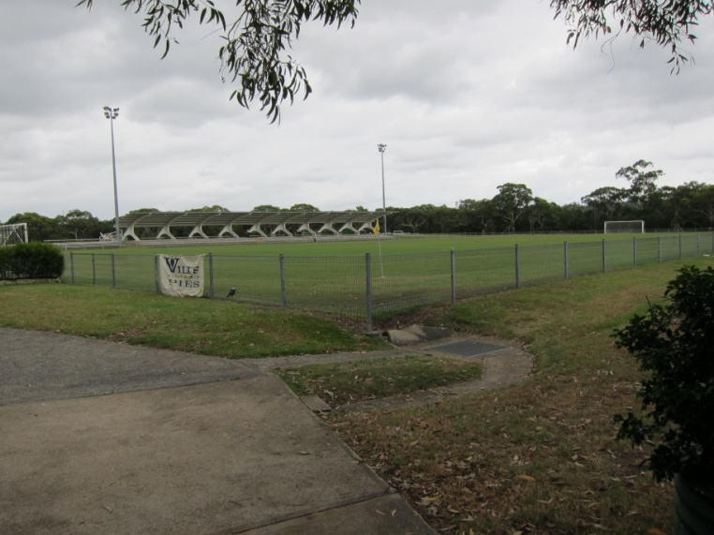  Control ...30..... | 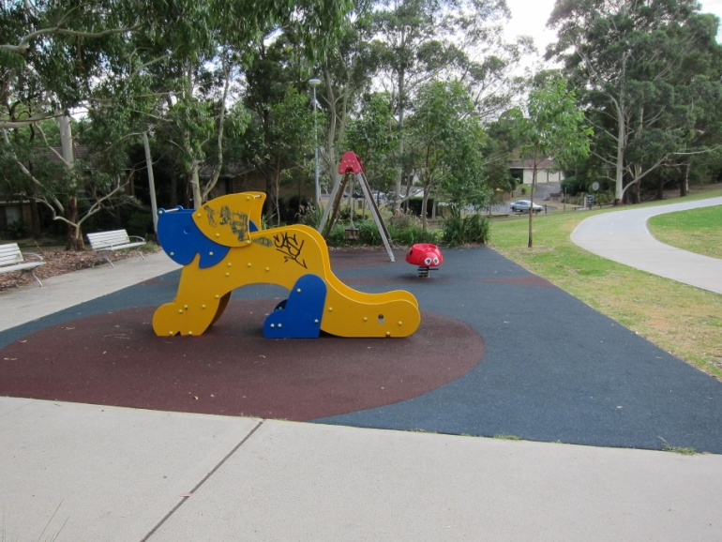  Control ...Start.....
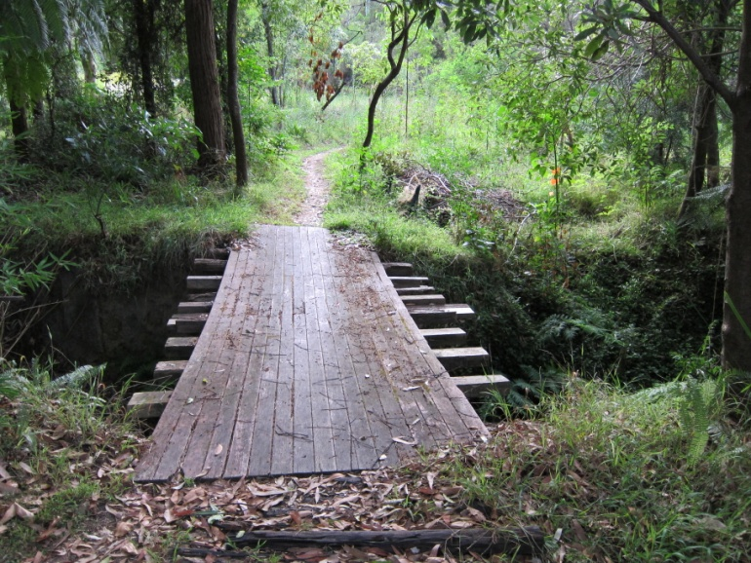  Control ...54..... | 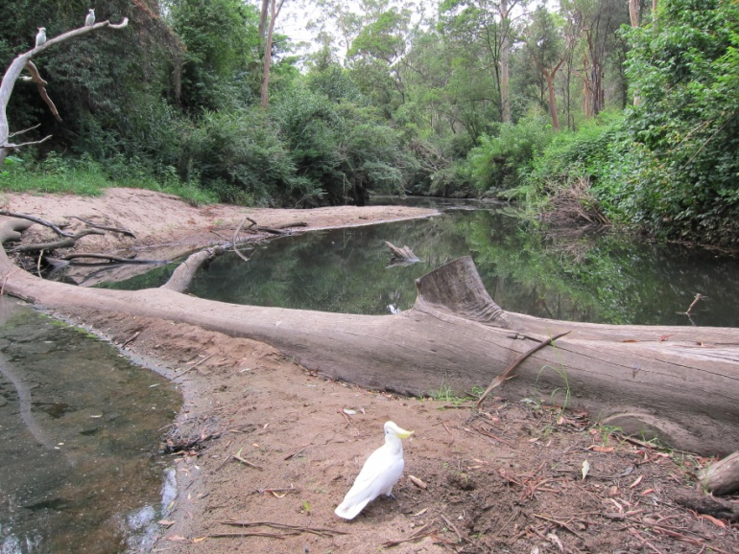  Control ...X2..... | 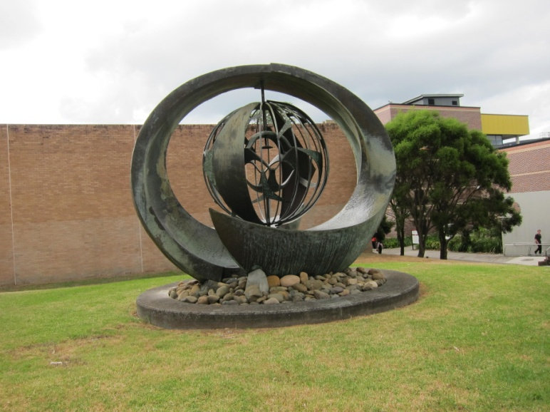  Control ...53

Administration and Emergency Contact Number 0413 905 551 or 0419 663 539
Clues

No. | Question | A | B | C | Ans.
Controls at or near X-ings of the Lane Cove River - 100 Points
X1 | No. of posts in green metal fence | 4 | 5 | 7 | C
X2 | Max. height of flood indicator | 1m | 2m | 2.5m | B
X3 | Object hanging over 1.5m high waterfall rock-face, 20m upstream of creek crossing | shopping trolley | 5m long timber plank | car wreck | B
X4 | Sign on tree trunk to ... | University | Marsfield | Christie Park | B
X5 | No. of street lights on De Burghs Bridge (within white fences) | 14 | 18 | 20 | A
Add 250 Bonus Points if you visit 4 or more of the River X-ing Controls |  |  |  |  | 250?
10 Points
10 | No. of wheel valves in hydrant | 2 | 4 | 6 | C
11 | Store on Level 5 in Macquarie Centre | Target | Woolworths | Myer | B
12 | Vine pattern on fence | squares | rectangles | circles | B
13 | First 560 bus on Sunday | 8:48am | 9.02am | 9.38am | C
14 | Australian politician | Abbott Ave | Garrett Ave | Rudd Rd | B
15 | CAUTION ... | Aged Care Home | Children at Play | Road hump | B
16 | Man-made object | flag pole | plaque | bubbler | C
17 | No. of lights in M2 walkway | 7 | 9 | 11 | C
18 | No. of concrete pylons supporting M2 bridge | 6 | 8 | 10 | B
19 | No. of timber cubby houses | 1 | 2 | 3 | B
20 Points
20 | Faded yellow-backed sign on tree erected by ... | Sydney Water Board | Forestry Commission | Sydney Electricity | B
21 | No. of timber slats in seat | 8 | 10 | 12 | A
22 | Sign at bottom of 70A driveway | Beware Dog | STOP | No Hawkers | B
23 | No. of concrete beams supporting M2 overpass | 9 | 11 | 14 | B
24 | No. of skylights in Equestrian Centre roof | 11 | 13 | 15 | B
25 | Electricity kiosk number | 4646 | 4647 | 4648 | A
26 | Community Garden Club meets ... | 1st Sunday | 2nd Sunday | 3rd Sunday | A
27 | Mobile phone repeater station | Vodafone | Optus | Telstra | C
28 | The ‘Field of Dreams’ is the home of the ... | Angels | Devils | Saints | A
29 | No. of chrome pillars in car grill | 2 | 4 | 6 | B
30 Points
30 | Animal on GHFA emblem | tiger | kangaroo | koala | C
31 | Stormwater storage capacity beneath Oval (sign W of toilets) | 150,000L | 200,000L | 400,000L | C
32 | Padlock, locking double gates | ABUS | Chubb | Lockwood | A
33 | No. of solar powered street lights | 6 | 8 | 10 | B
34 | Building F9C | CSIRO | METS | PACE | C
35 | No. of holes in cube sculpture | 3 | 4 | 6 | B
36 | Date of ‘Coil’ sculpture | 2000 | 2003 | 2007 | B
37 | Distance to Newcastle | 228km | 233km | 238km | A
38 | Track surface | concrete | rock | soil | A
40 Points
40 | Colour of rocking tortoise on spring | green | brown | red | A
41 | Toilet on N side of Block | GENTS | MEN | WOMEN | A
42 | Area of Turpentine Ironbark Forest remaining in Sydney (km2) | 11 | 22 | 33 | A
43 | No. of galvanised steel slats between brick walls | 16 | 18 | 20 | A
44 | Colour of small horizontal arrow on tree (N and S sides), W of track | yellow on black | brown on white | black on green | B
45 | No. of slippery dip steps | 5 | 7 | 8 | A
46 | Name of Macquarie University Project | Sustainable Water | Waterwise | Recycled Water | A
47 | No. of observatory domes | 1 | 2 | 4 | B
48 | Unit Block name | Blackwood | Pinewood | Oakwood | C
49 | Scoreboard donated by Year 12 ... | 2000 | 2003 | 2005 | C
50 Points
50 | No. of concrete water tanks | 3 | 4 | 5 | A
51 | No. of 1m high black light posts | 5 | 7 | 9 | B
52 | No. of circular holes in upper rock platform, S of boardwalk | 10 | 13 | 19 | C
53 | Fabricator of ‘From Northpoint’ sculpture | Keith Jackson | Ken Jackson | Kerry Jackson | A
54 | No. of cross beams supporting bridge deck | 8 | 12 | 16 | B
55 | No. of units in UnitingCare Northaven (Hint: letterboxes) | 24 | 29 | 35 | B
56 | ‘On duty 24 hours’ at No. 99 | German Shepherd | Vet | WIRES | A
57 | Number of 300mm diam. storm-water pipe exits | 2 | 4 | 6 | A
58 | Max. pressure of water meter | 1600kPa | 2000kPa | 2300kPa | A
59 | House 19 letterbox | dolls house | milk urn | drum | B
60 Points
60 | Year of Foundation Stone | 1961 | 1965 | 1966 | C
61 | Number on sewer manhole lid (in track) | WBS211 | WBS212 | WBS213 | A
62 | Church services at 9.00am and ... | 6.00pm | 6:30pm | 7.00pm | C
63 | No. of tall gum trees in front yard of No. 41 | 1 | 3 | 6 | B
64 | Electricity pole number | PY23109 | PY23111 | PY23113 | A
65 | No. of spokes in back wheels of Steam Roller | 4 | 6 | 8 | B
66 | No. of arrows on road corner (SW side) | 4 | 5 | 8 | C
67 | Words on sign that are most faded | COUNCIL | BY ORDER | PENALTY $100 | C
68 | Name on House 7 | The Castle | KAHN | Shangri-la | B
69 | Colour of school metal gates | blue | red | yellow | A
70 Points
70 | Goal posts | soccer/rugby | soccer | rugby | A
71 | Man-made construction | BBQ | bike circuit | fireplace | B
72 | Electricity tower number | PY02200 | PY02210 | PY02220 | B
73 | The subject of notice on fence | Players | Dog owners | Spectators | C
74 | No. of Community Fire Unit | FHP 151 | FHP 168 | FHP 170 | A
75 | Colour of swings’ pole | yellow | purple | red | B
76 | Shop at E end of N block | munch Delicafe | Dry Cleaners | IGA | A
77 | Height of waterfall 15m N of track | 2m | 5m | 10m | A
78 | No. of gum trees within path circle | 3 | 5 | 7 | A
79 | No. of spokes in steering wheel of car wreck, 20m E of track | 3 | 4 | 5 | A
80 Points
80 | School phone number | 44 7584 | 944 7584 | 9944 7584 | A
81 | Letters on metal cross members above pipe | TC | AA | AB | A
82 | No. of 0.5m rocks along E of track | 4 | 7 | 10 | B
83 | No. of TV aerials on rear roof of House 42 | 1 | 2 | 3 | B
84 | No. of steps E side of creek | 5 | 7 | 8 | A
85 | Man-made object, 10m S of track | signpost | sewer manhole | concrete foundation | C
86 | Weir material damaged by floods | asphalt | concrete | timber | B
87 | No. of roses along front of No. 10 | 4 | 8 | 12 | C
88 | Distance to Thornleigh Oval | 7.2km | 7.6km | 7.9km | B
89 | Words on top of pole in centre of rope climber | Aus Play | Berliner Seilfabrik | Childs Play | B
90 Points
90 | Saturday opening hours for Pool | 10–6 | 9-5 | 8-5 | A
91 | No. of pipes under concrete in creek bed | 1 | 3 | 4 | A
92 | No. of concrete steps beside track (W side) | 2 | 4 | 5 | A
93 | Height of sewer manhole 40m N of track | 100mm | 500mm | 1m | C
94 | Material of 2.5m high, 50mm diam. pole (NW of track junction) | galv steel | timber | plastic | A
95 | Letters on 1m post ,6m E of track | AV | FH | SW | A
96 | Shop at S end | Bakehouse | Chemist | Newsagent | A
100 Points
100 | No. of steps carved into rock W of creek | 5 | 7 | 10 | A
101 | No. of 1m posts in E side fence | 4 | 7 | 10 | B
102 | No. of ‘counters’ in abacus | 12 | 9 | 6 | B
103 | No. of white cross members in top deck railing at back of cream house | 2 | 4 | 6 | B
104 | Number of swings in backyard | 0 | 1 | 3 | B
105 | Colour of 100mm square on post (great view) | blue | red | yellow | C
106 | Number of Sydney Water kiosk | WS0097P01 | WS0097P02 | WS0097P03 | B
107 | Number of white Shipping Container | 3405847 | 3405848 | 3405849 | C
108 | Animal structure in backyard behind 1m high green wire fence, 30m W of track | aviary | kennel | chook pen | A
109 | Electricity tower number | PY02201 | PY02203 | PY02205 | A

