
What is Rogaining?  Rogaining is the sport of long distance cross-country navigation, in which teams of two to five people visit as many checkpoints as they wish in a set time period. The traditional Rogaine is 24 hours in duration, however, there are also shorter events of 3, 6, 12 and 15 hours. Most NSW events are held within 2 to 3 hours of Sydney. Most rogaines are on foot and held in attractive bush and farmland locations. However, some events are held in metropolitan areas (Metrogaines), or on bikes (Cyclegaines). Rogaining is an adventure sport and is a lot of fun. | 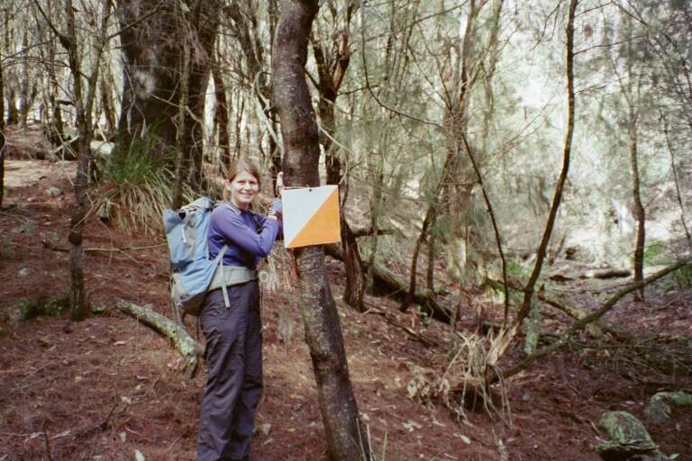
Who is it for?  Rogaining is a team activity for people of all ages and levels of fitness. Everyone from elite athletes to families with young children can enjoy rogaining. New rogainers are always welcome and assistance is always available from the organiser to help get novices started. The parts of the course you visit are entirely up to you and your team members. There are no set routes and you don’t have to spend the whole time on the course. You can return to the hash house at any time for hot food and rest around the campfire, or sleep on long events, before heading out again. Some competitive teams may cover over 50km in a 12 hour event and more than 100km in an event of 24 hours. However, the distance you travel is entirely up to you. Satisfaction comes in finding your way around the course, according to the route you have chosen, and navigating back to the finish within the time limit. | 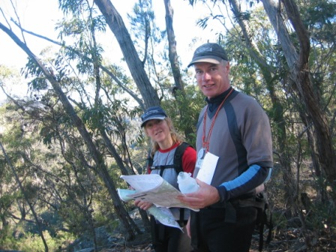
What do you need?  Rogaining is good value for money. All you need is basic bushwalking gear including a compass, whistle, water bottle, comfortable and warm clothes and shoes, a waterproof jacket and a basic first aid kit. On 12 and 24 hour events you may also wish to bring along camping gear and spend overnight at the Hash House.  What does it cost?  In New South Wales the entry fees vary from $40 to $90 depending on the event. This covers hot food during the event, your map, information sheets and facilities at the hash house. All events offer a concession fee. Children under 14 have free entry. | 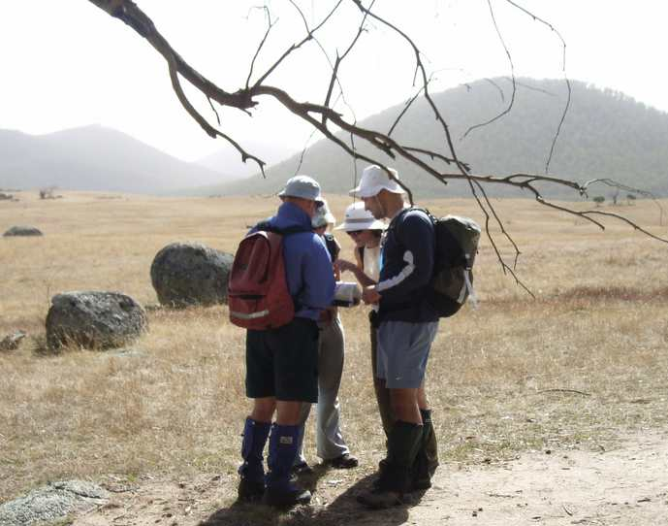
How does it work?  Between 2 and 3 hours (depending on the length of the event) before the start of the event you get a map with all the control locations marked on it. You also receive a description of the control points and their point value. The idea is you choose your own route to get whatever controls you want. Make sure that you get back before the time limit expires as there are hefty point penalties for being late.  At each control there is an electronic unit that records your visit. Rogaining is a team sport and for safety reasons, the team must stay together at all times. | 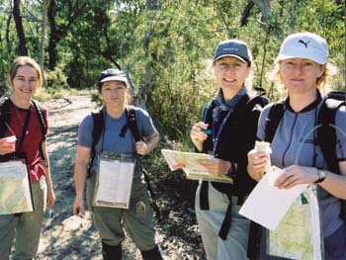
Who is the NSW Rogaining Association?  The NSW Rogaining Association is a volunteer, non-profit incorporated association that organises about six rogaines each yeary.  Further Information  Visit the NSW Rogaining Association’s web site:  www.nswrogaining.org | 